Figure 7e: The representative images of mitral flow patterns detected by cardiac ultrasound.

HFpEF

E/A

Control

AP-7

Vehicle

CMF-019

AP-16

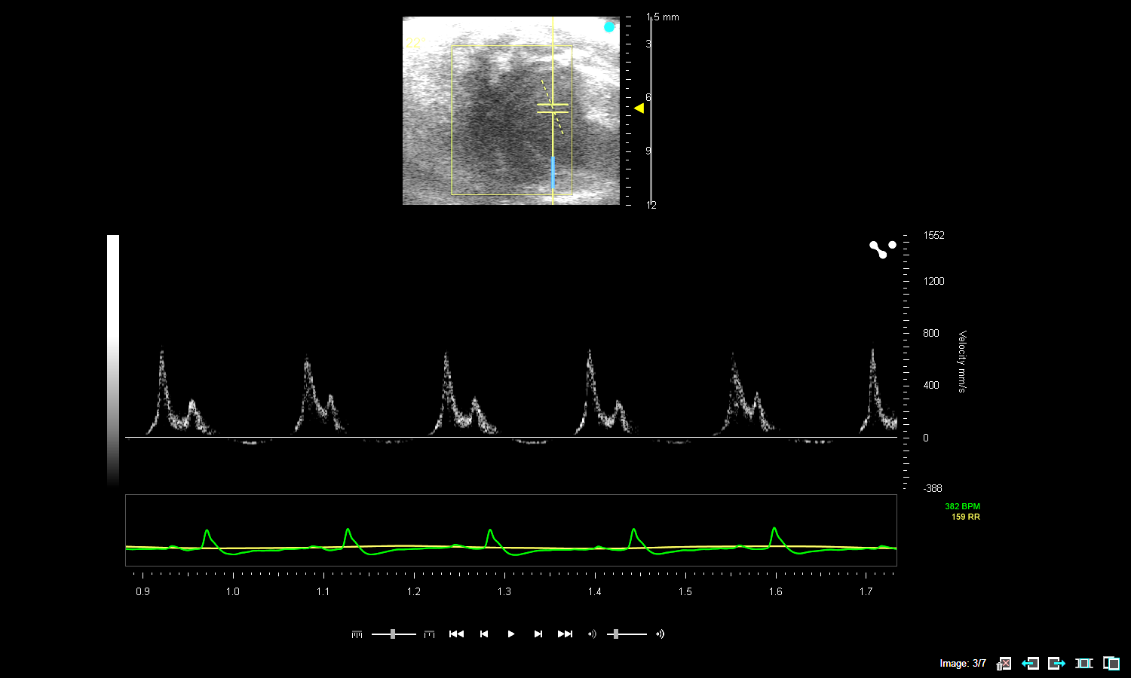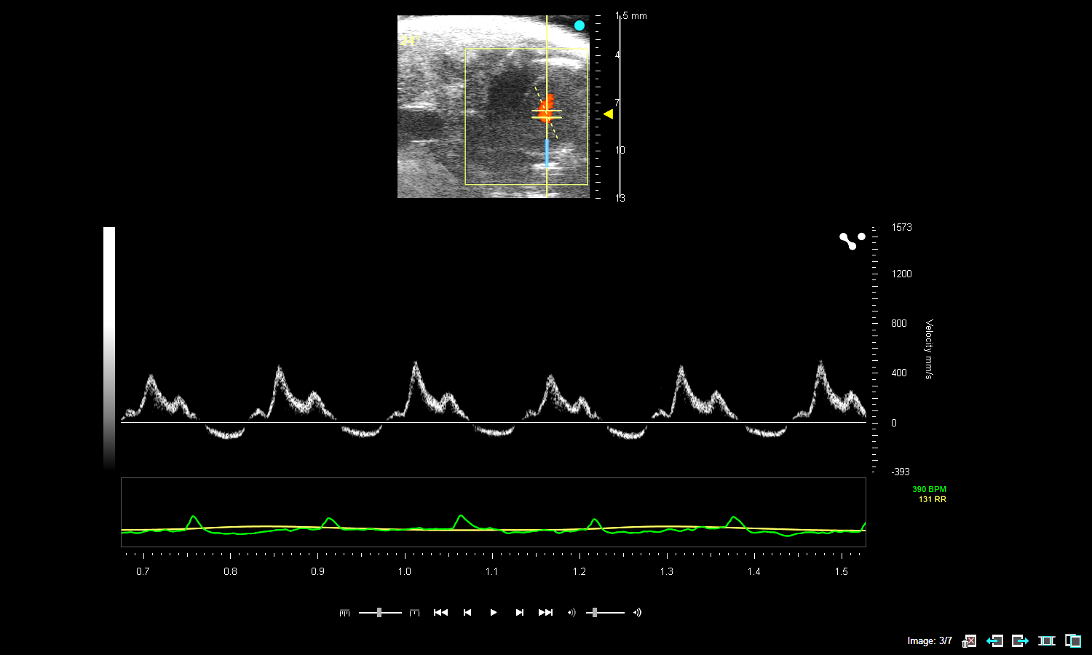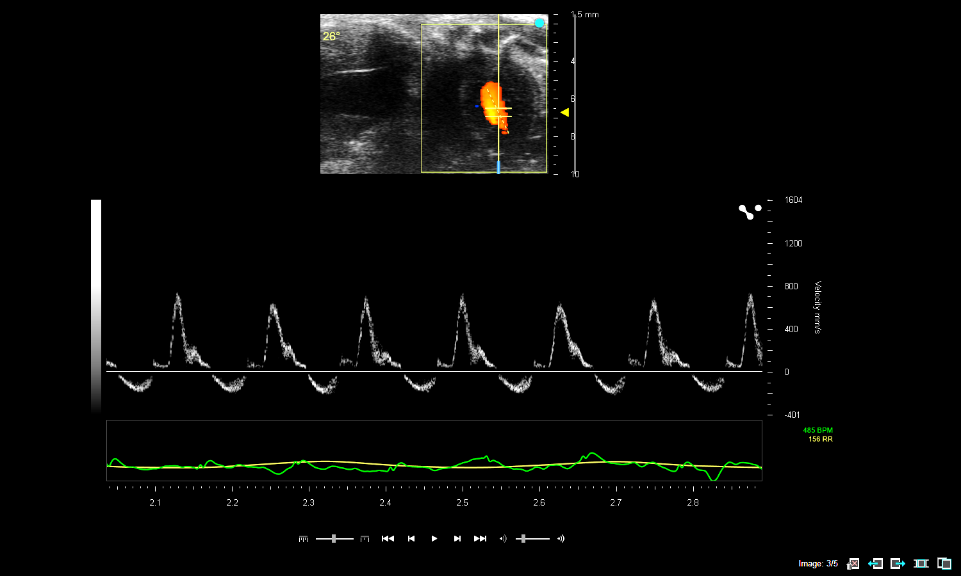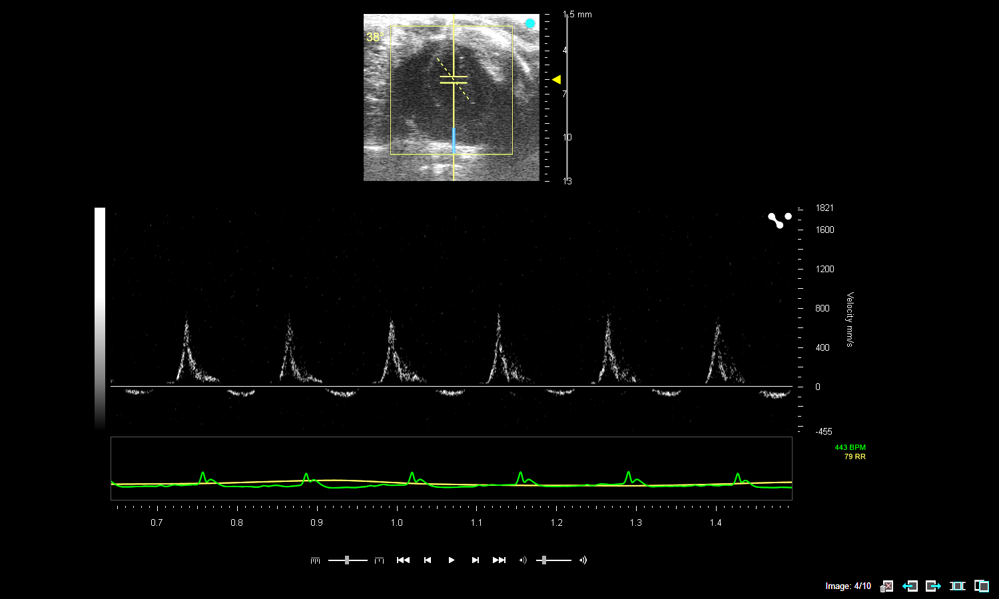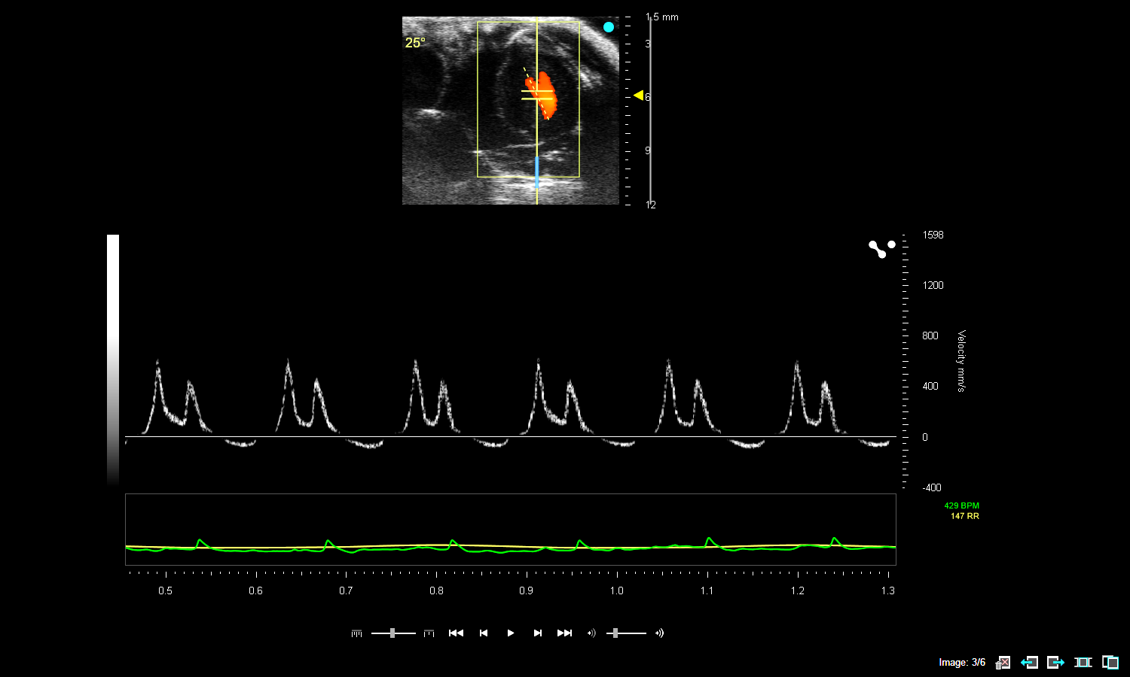

E/e’

HFpEF



Control

Vehicle

CMF-019

AP-16

AP-7

Extended Data Figure 9a: Representative ultrasound view of heart from different experimental groups.

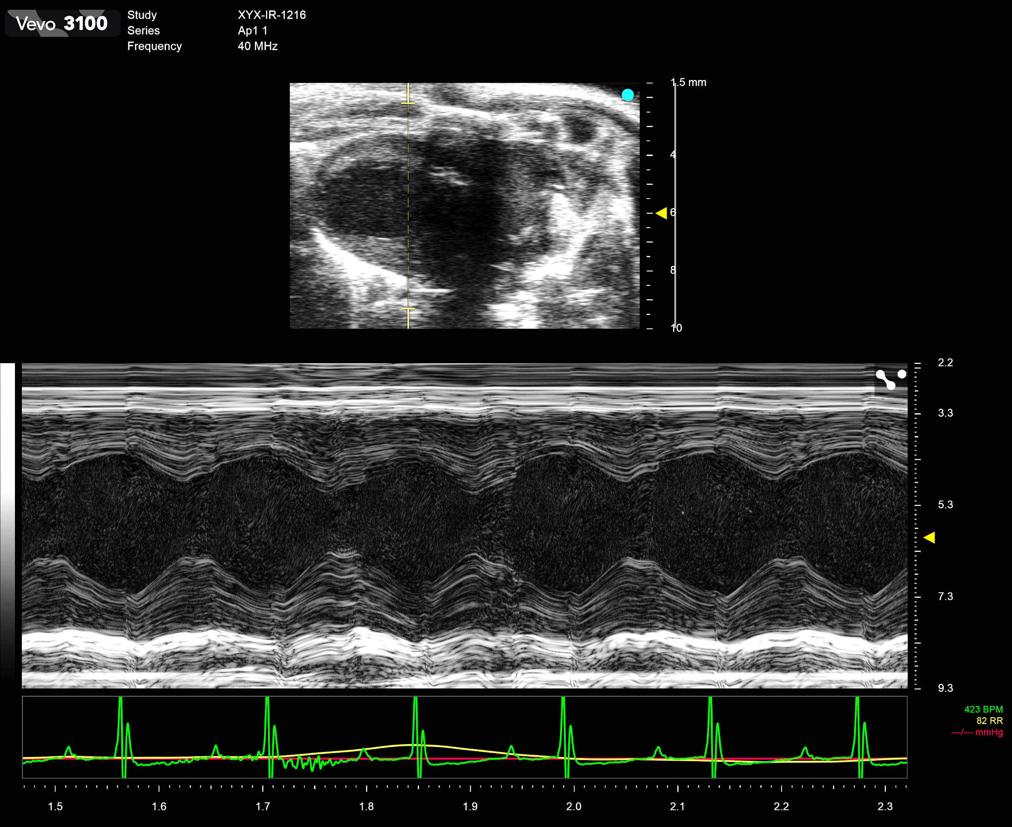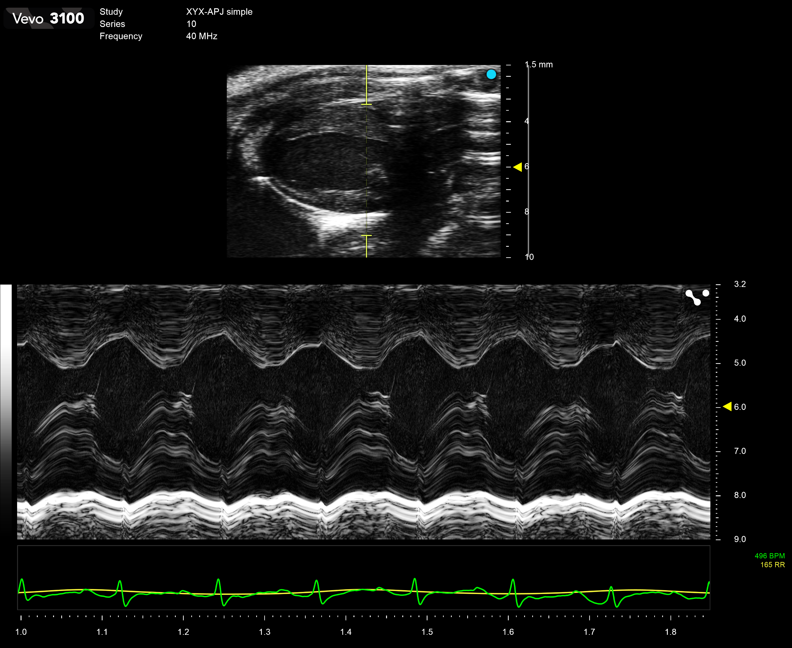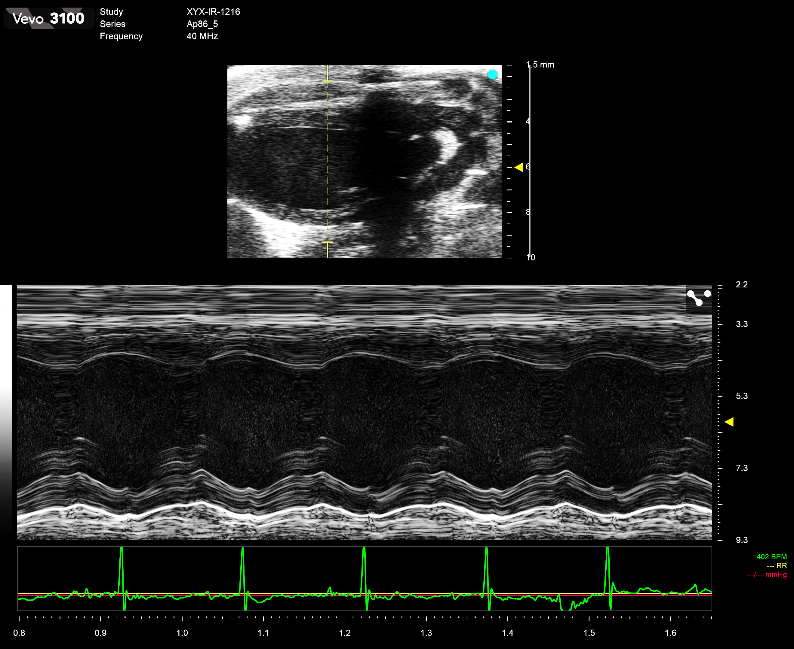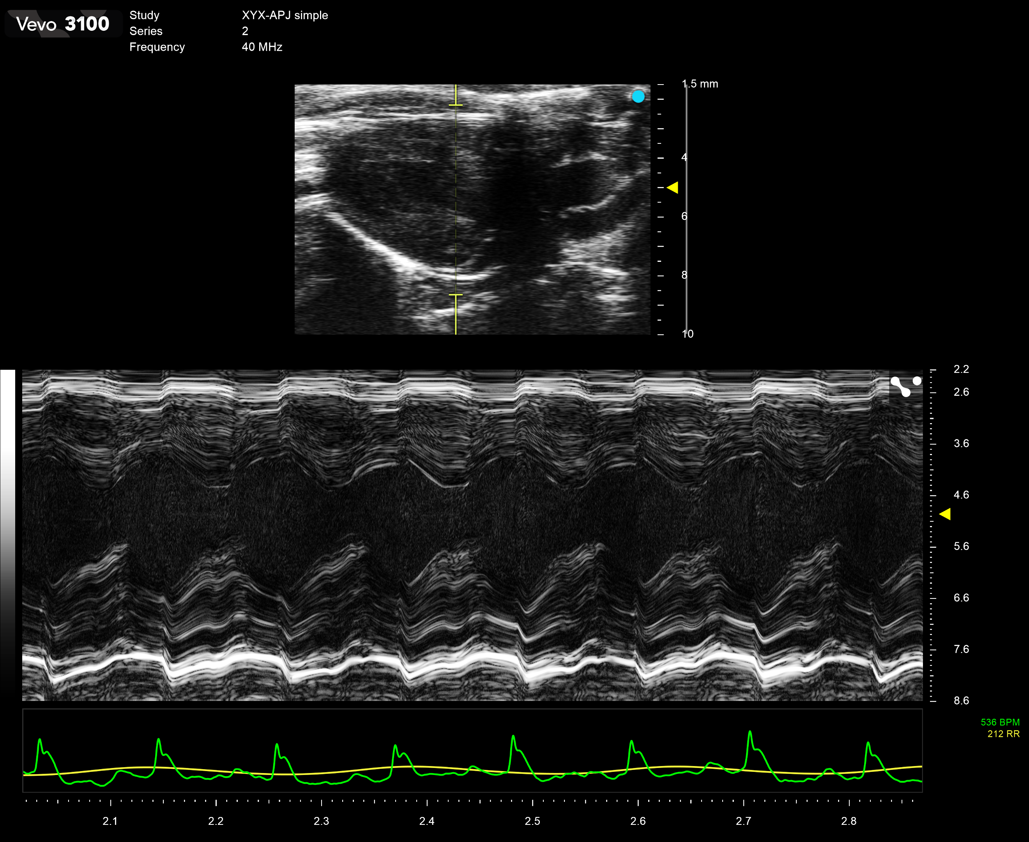Vehicle CMF-019 AP-7 AP-16

Extended Data Figure 10h: Representative ultrasound view of heart from different experimental groups.

CMF-019

HFpEF

AP-16

AP-7

Vehicle

Control

